1. Introduction
PEA is an endogenous lipid mediator with a unique chemical structure, scientifically known as N-Palmitoylethanolamine.5 Chemically, this molecule is composed of palmitic acid and ethanolamine, exhibiting certain lipophilicity and biological activity. PEA is primarily endogenously generated in the human body and is obtained from natural sources such as egg yolks, soybeans, and peanuts, which provides the possibility to regulate the level of PEA in the body through die.
(PEA) has emerged as a potential nutraceutical, because this compound is naturally produced in many plant and animal food sources, as well as in cells and tissues of mammals, and is involved in important neuroprotective, anti-inflammatory and analgesic actions.
Novel formulation forms such as microparticle and ultra-microparticle forms can significantly improve its bioavailability, resulting in more ideal pharmacokinetic properties and therapeutic potential in clinical applications
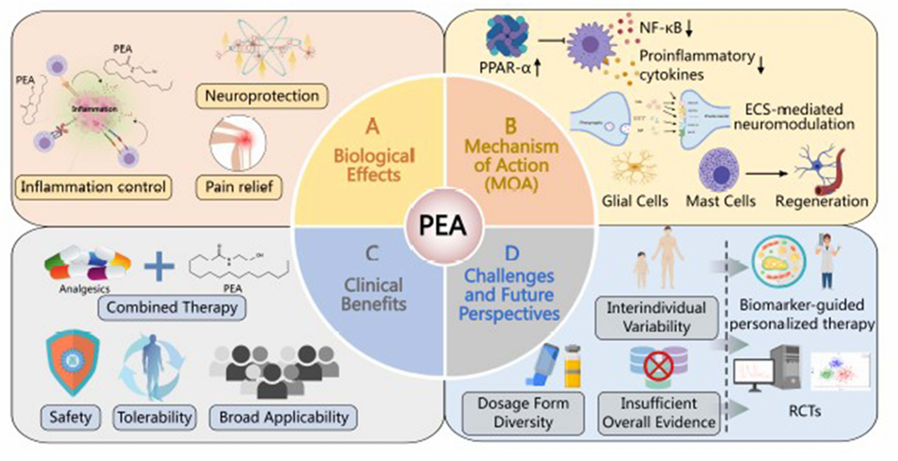

2. Why is PEA important?
As a naturally occurring lipid mediator, PEA not only participates in regular cellular energy metabolism but is also known for regulating inflammatory responses and pain conduction.
PEA not only exhibits notable anti-inflammatory and analgesic effects, but also has an extremely low incidence of adverse reactions, demonstrating good safety in special populations (such as the elderly and pregnant women). This high safety profile and broad therapeutic window make PEA suitable not only as a standalone therapy but also highly appropriate as an adjunct medication in combination treatments, reducing the dosage of main drugs such as NSAIDs & opioids and the associated risk of side effects.
Simultaneously, its combination with other natural antioxidants or anti-inflammatory constituents can further enhance the overall analgesic effect and improve quality of life.

3. The Mechanism of Action of PEA:
The pharmacological action of PEA is mainly done through regulation of the inflammatory cascades, antioxidant effects, neurotrophic effect, and spinothalamic pain pathway modulation. These various effects are done through PEA action directly or indirectly on many targets.
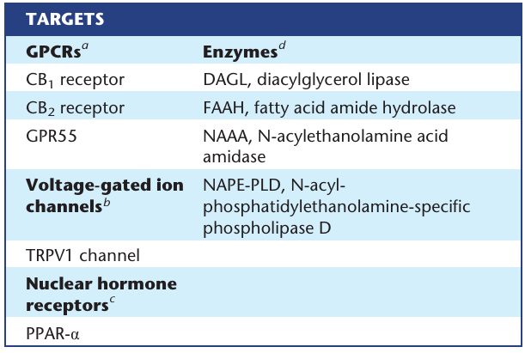

3.1 PPAR-α Activation
PEA produces its anti-inflammatory and analgesic effects primarily by activating PPAR-α. This activation regulates key signaling pathways, inhibiting both NF-κB (reducing pro-inflammatory factors) and p38-MAPK (modulating neuroinflammation). These effects, demonstrated in both in vitro and in vivo studies, are dependent on the PPAR-α pathway.

3.2 The Companion Effect of PEA and the Endogenous Cannabinoid System
PEA enhances the endogenous cannabinoid system (ECS) indirectly through an "entourage effect." It does not directly bind to cannabinoid receptors but instead inhibits the FAAH enzyme. This inhibition increases levels of endocannabinoids like AEA, which then activate CB1 and CB2 receptors to alleviate pain and inflammation. This synergistic approach provides therapeutic benefits without the psychoactive side effects of direct cannabinoid activation.

3.3 Regulation of the Activation of Glial Cells and mast cells
PEA alleviates neuroinflammation and chronic pain by inhibiting the overactivation of glial cells (microglia and astrocytes). This inhibition reduces the release of pro-inflammatory cytokines like IL-1β and TNF-α. PEA achieves this through multiple signaling pathways, including both PPAR-α-dependent and independent routes (e.g., TLR4/NF-κB), and by reducing p38-MAPK activity. This effect is demonstrated in both cell experiments and animal models. PEA also helps manage neuropathic pain by targeting Mast Cells by stabilizing them, preventing the release of pro-inflammatory substances.

3.4 Mechanisms of Antioxidant Stress and Anti-Inflammatory Regulation
PEA combats oxidative stress, a key factor in neuropathic pain, through antioxidant mechanisms. It activates the Nrf2/HO-1 pathway to upregulate antioxidant enzymes and directly scavenges harmful free radicals like ROS. Furthermore, PEA regulates mitochondrial function and improves cellular energy metabolism via the AMPK pathway, which helps break the cycle of inflammation and oxidative stress.

3.5 Effects on Ion Channels, Neurotrophic Factors, and Synaptic Plasticity
PEA exerts analgesic effects by modulating key ion channels like Nav1.7 and Cav3.2, reducing neuronal hyperexcitability. It also upregulates the expression of brain-derived neurotrophic factor (BDNF), which promotes neural repair and reverses the maladaptive synaptic plasticity associated with chronic pain. Through these mechanisms, PEA restores normal neural function and alleviates pain.

3.6 GPR55 receptor
The GPR55 receptor, though distinct from CB1 and CB2, is activated by certain cannabinoids. Evidence suggests that PEA can also directly activate GPR55, though this is considered controversial. This receptor is expressed widely in the brain and periphery (e.g., the gastrointestinal tract) and is a putative target for treating inflammation. Its activation triggers downstream signaling events, including increases in intracellular calcium and the activation of pathways like ERK, MAPK, NF-κB, and CREB.

3.7 TRPV1
The TRPV1 channel is a non-selective cation channel activated by various physical and chemical stimuli, including capsaicin and endocannabinoids like AEA. It is primarily found in sensory neurons and is a key player in pain transmission and inflammation. Its activity is regulated by phosphorylation, which sensitizes it, and calcium-induced desensitization, which inactivates it and produces analgesic effects.

3.7.1 PEA influences TRPV1 through two indirect mechanisms:
- Entourage Effect: PEA allosterically enhances the activation and subsequent desensitization of TRPV1 channels induced by endocannabinoids like AEA and 2-AG.
- PPAR-α Interaction: PEA activates PPAR-α receptors, which have been shown to biochemically interact with and desensitize closely-associated TRPV1 channels.
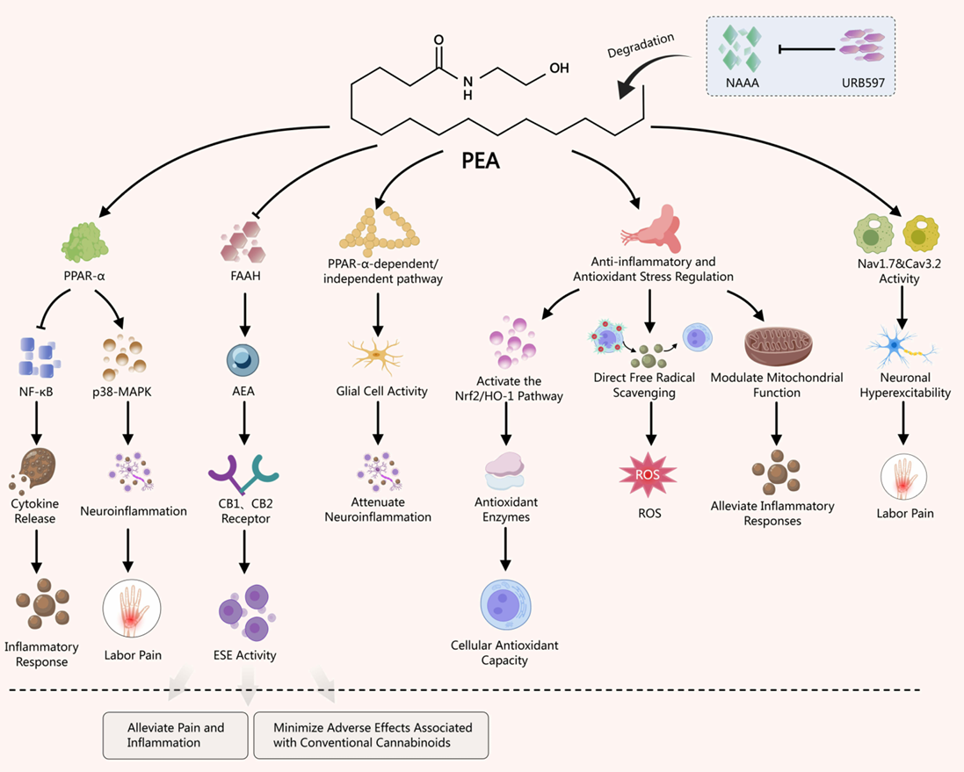
a summary of the mechanisms of PEA.

4. Pharmacokinetics of PEA
PEA has inherently poor water solubility and is rapidly degraded by enzymes (NAAA, FAAH), which limits its oral absorption and bioavailability, leading to short-lived action and low brain penetration.
To overcome these limitations, new formulations have been developed:
- Oil-based emulsions for subcutaneous injection effectively deliver PEA to tissues, including the brain, for extended periods (24-48 hours).
- Micronized (m-PEA) and ultra-micronized (um-PEA) formulations for oral administration significantly improve its absorption and bioavailability by reducing particle size to increase solubility.
particle size reduction is a key strategy to enhance PEA's solubility and overcome its pharmacokinetic challenges.

5. Clinical Applications

5.1 Current Status of Clinical Research on Different Pain Types
Clinical studies indicate PEA shows promise in treating various chronic and neuropathic pain conditions. Key findings include:
- Fibromyalgia & Chronic Pain: As an add-on therapy, PEA combined with other compounds (like ALC) significantly improved pain scores and quality of life measures in patients.
- Low Back Pain: Ultra-micronized PEA (umPEA), combined with physical therapy, effectively reduced pain intensity and disability.
- Chemotherapy-Induced Neuropathy (CIPN): Preclinical research suggests PEA has neuroprotective properties, mitigating the toxic effects of chemotherapeutic drugs on neurons.
- Other Pain Types: Preliminary data shows potential benefits for osteoarthritis, sciatica, and chronic pelvic pain (e.g., interstitial cystitis), often in combination with other anti-inflammatory or antioxidant compounds.
A meta-analysis concluded that micronized/ultra-micronized PEA effectively reduces pain intensity across various chronic pain types, independent of a patient's age, sex, or the specific pain etiology.

5.2 PEA as an Adjunct or Combination Therapy
PEA enhances the efficacy and reduces the side effects of conventional pain medications like NSAIDs and opioids through synergistic mechanisms. It achieves this by:
- Activating PPAR-α to reduce inflammatory mediators, thereby boosting the anti-inflammatory effect of NSAIDs.
- Modulating the endocannabinoid system to affect pain signaling, thereby enhancing the analgesic effect of opioids.
Clinically, this synergy allows for a reduction in the required dosage of opioids (mitigating side effects like constipation and nausea) and decreases the gastrointestinal and organ toxicity associated with NSAIDs. Preclinical evidence confirms that a combination of PEA and paracetamol can effectively reduce pain, inflammation, and nerve damage. In summary, PEA offers a strategy to improve pain treatment outcomes while lowering the risks of conventional drug therapy.

5.3 Combined Treatment Cases with Other Natural Antioxidants
PEA demonstrates enhanced therapeutic effects when combined with natural antioxidants and anti-inflammatories, such as alpha-lipoic acid and L-carnitine. These combinations work through complementary mechanisms, synergistically reducing oxidative stress, protecting nerve cells, and alleviating pain.
Clinical studies support this approach, showing that such combinations lead to significant improvements in conditions like diabetic neuropathy and fibromyalgia. This strategy provides a broader and more comprehensive treatment option for chronic pain.

5.4 Neurodegenerative diseases
- Alzheimer's Disease (AD): PEA reduces behavioral impairments, oxidative stress, and neuroinflammation in mouse models. It counteracts astrocyte activation, reduces the expression of amyloidogenic proteins, and restores cognitive function. These effects are blocked by PPAR-α antagonists, confirming the receptor's crucial role.
- Parkinson's Disease (PD): In a neurotoxin-induced PD model, chronic PEA treatment protected nigrostriatal neurons, reduced glial activation, and improved motor function.
- Amyotrophic Lateral Sclerosis (ALS): A clinical study in ALS patients showed that ultra-micronized PEA (um-PEA) slowed the decline of respiratory function and reduced the desensitization of muscle receptors, suggesting it could help conserve muscle excitability as an add-on treatment.

Mechanism: The neuroprotective effects are largely dependent on the activation of the PPAR-α receptor. Furthermore, a composite of PEA and the antioxidant luteolin (co-ultra PEA-Lut) shows enhanced efficacy, combining anti-inflammatory and antioxidant actions.
preclinical evidence strongly supports PEA's role in mitigating neuroinflammation and neuronal damage, with preliminary clinical data indicating potential benefits for slowing disease progression in ALS.

5.5 PEA and pain perception
Micronized (m-PEA) and ultra-micronized (um-PEA) formulations are effective in clinical studies for treating various chronic pain conditions, including:
- Diabetic neuropathy
- Lumbosciatalgia (sciatica)
- Inflammatory pain
- Pelvic pain (e.g., endometriosis), especially when combined with the antioxidant polydatin.
The analgesic effect is progressive, well-tolerated, and lacks significant toxicity or adverse events. One study in long-term spinal cord injury (SCI) patients did not find um-PEA effective, suggesting it may be most beneficial when administered in earlier stages of injury.
PEA is a promising therapeutic strategy that modulates pain perception through several complementary pathways, offering effective and safe relief for various chronic pain conditions.

5.6 PEA as an anti-inflammatory agent
PEA exerts its potent anti-inflammatory effects primarily by modulating mast cell activation and degranulation, a mechanism known as Autacoid Local Inflammation Antagonism (ALIA). Its action is mainly mediated through the activation of the PPAR-α receptor, which inhibits the NF-κB pathway and the release of pro-inflammatory cytokines.
A key mechanism is the "entourage effect," where PEA indirectly enhances the activity of the endocannabinoid system, increasing levels of anandamide (AEA) and 2-AG to exert broader anti-inflammatory actions.
PEA has demonstrated significant anti-inflammatory benefits in models of:
- Inflammatory Bowel Disease (IBD): Reducing colitis, improving macroscopic signs, and inhibiting disease-associated angiogenesis.
- Dermatological Conditions: Effectively reducing skin inflammation, pruritus, and lesions in models of contact allergic dermatitis and canine atopic dermatitis.
- Ocular Inflammation: Attenuating uveitis and preserving the blood-retinal barrier in diabetic retinopathy.
- Cystitis: Reducing bladder inflammation and associated pain.

5.7 PEA in neuropathic pain
Palmitoylethanolamide (PEA) is effective in treating both peripheral and central neuropathic pain by targeting their root causes: inflammation and nervous system dysfunction.

5.7.1 Key Mechanisms of Action:
PEA works through several interconnected mechanisms:
- Reduces Neuroinflammation: It powerfully calms inflammation in the nervous system, a central driver of neuropathic pain.
- Modulates Immune Cells: It stabilizes mast cells and other immune cells, stopping them from releasing pro-inflammatory substances.
- Activates Receptors: It engages molecular targets like the PPAR-α receptor and CB2 receptors on immune cells to regulate the immune response and reduce pain.
- Calms Glial Cells: In the central nervous system, it reduces the overactivation of microglia and astrocytes, which are key contributors to chronic pain states.
- Antioxidant Effects: It increases antioxidant defenses, reducing oxidative stress linked to pain (e.g., from chemotherapy drugs like oxaliplatin).
- Affects Pain Pathways: It interacts with channels like TRPV1 to modulate pain signaling within the central nervous system.
Applications for Pain Types:
- Peripheral Neuropathic Pain: PEA is highly effective for conditions like diabetic neuropathy, post-herpetic neuralgia, and chemotherapy-induced neuropathy by resolving local inflammation and immune dysregulation.
- Central Neuropathic Pain: PEA helps manage pain originating from within the central nervous system (e.g., from multiple sclerosis or spinal cord injury) by targeting glial cell activation and central sensitization, offering both pain relief and neuroprotection.

6. Dose dependent effects of PEA on CNS lipidomes (study summary)
This research team conducted a first-of-its-kind study to see how PEA affects the brain. They gave awake rats different doses of PEA and used two advanced techniques: MRI to measure brain activity and "lipidomics" to measure fat molecules in the blood and brain.
They found two surprising, seemingly opposite results:
- Higher doses of PEA decreased overall brain activity in specific regions.
- Higher doses of PEA increased communication between those same brain regions.
They also discovered that PEA doesn't just act on its own; it causes a major shift in the levels of many natural fat-based signaling molecules in the brain, including the famous "bliss molecule," anandamide.

6.1 Detailed Explanation:
1. The Goal and Methods
- Goal: To understand how PEA affects brain function and the chemistry of lipids (fats) in the body and brain. This had never been studied in this comprehensive way before.
- Methods:
  - They gave rats one of three doses of PEA (3, 10, or 30 mg/kg) or a placebo ("vehicle").
  - While the rats were awake, they used MRI scans to measure two things:
    - BOLD signal: This measures local brain activity (how much energy a specific area is using).
    - Functional connectivity: This measures how well different brain regions are communicating with each other.
  - After the scans, they measured levels of PEA and over 80 other endogenous lipids (naturally occurring fat molecules) in the blood and brain.

6.2 The Key Findings on Brain Activity (MRI)
The MRI results revealed a fascinating and dual effect:
- Finding #1: Inverse Dose-Response in BOLD Signal
  - What it means: The higher the dose of PEA, the lower the brain activity ("negative BOLD") became.
  - Affected Areas: This calming effect was seen in critical areas like the prefrontal cortex (for decision-making), sensorimotor cortices (for movement and sensation), basal ganglia, and thalamus (relay stations for information).
  - Interpretation: PEA seems to have a generally quieting or stabilizing effect on neural activity in these regions.
- Finding #2: Dose-Dependent Increase in Functional Connectivity
  - What it means: The higher the dose of PEA, the stronger the communication and coordination became between the very same brain areas that showed decreased individual activity.
  - Interpretation: Even though each individual area was less active, the network of these areas became more synchronized and efficient at working together.
Why this isn't a contradiction: Think of a well-coordinated team. You don't need everyone talking loudly and frantically (high individual activity) to be effective. You need calm, focused team members (lowered BOLD signal) who are listening and cooperating perfectly (increased connectivity). PEA may make the brain work more like that efficient team.

6.3 The Key Findings on Brain Chemistry (Lipidomics)
This was the other major discovery:
- PEA Levels: As expected, the highest dose (30 mg/kg) led to significantly higher levels of PEA in the brain.
- Other Lipid Levels: However, PEA's presence caused a ripple effect, significantly altering the levels of many other natural lipids.
  - Anandamide (AEA): Levels of this very important endocannabinoid (known for regulating mood and pain) decreased.
  - Widespread Changes: Of the 78 lipids detected, 51 were changed by PEA in at least one brain region. This suggests PEA doesn't just work alone; it profoundly influences the entire "signaling network" of lipids in the brain.
Overall Conclusion:
The study provides powerful evidence that PEA is not a simple stimulant or sedative. It drives substantial changes in CNS activity by:
- Calming local neural activity.
- Enhancing coordinated communication between brain regions.
- Acting as a master regulator, shifting the broader chemistry of lipid signals in the brain (including reducing anandamide).

Table of Contents
1. Introduction 1
2. Why is PEA important? 1
3. The Mechanism of Action of PEA: 2
3.1 PPAR-α Activation 2
3.2 The Companion Effect of PEA and the Endogenous Cannabinoid System 2
3.3 Regulation of the Activation of Glial Cells and mast cells 3
3.4 Mechanisms of Antioxidant Stress and Anti-Inflammatory Regulation 3
3.5 Effects on Ion Channels, Neurotrophic Factors, and Synaptic Plasticity 3
3.6 GPR55 receptor 3
3.7 TRPV1 3
3.7.1 PEA influences TRPV1 through two indirect mechanisms: 4
4. Pharmacokinetics of PEA 4
5. Clinical Applications 5
5.1 Current Status of Clinical Research on Different Pain Types 5
5.2 PEA as an Adjunct or Combination Therapy 5
5.3 Combined Treatment Cases with Other Natural Antioxidants 6
5.4 Neurodegenerative diseases 6
5.5 PEA and pain perception 7
5.6 PEA as an anti-inflammatory agent 7
5.7 PEA in neuropathic pain 8
5.7.1 Key Mechanisms of Action: 8
6. Dose dependent effects of PEA on CNS lipidomes 9

